Article 1:
Thousands of people queue for Pokémon centre pop up
A pop-up store by the Pokémon company, (open between October 18th, through to November 15th, 2019), came to London’s Westfield in Shepherds Bush for only 4 weeks and visitors experienced queues up to 8 hours long.
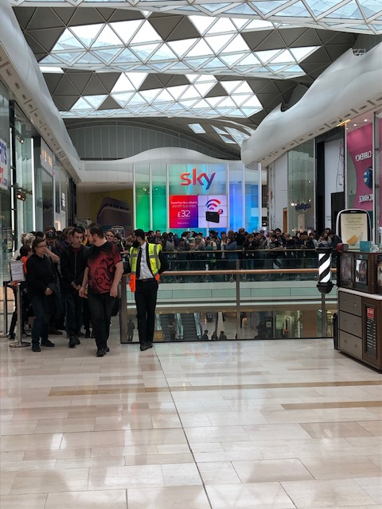
Pokémon is a game franchise that is popular around the world and has a game catalogue, toy catalogue and even a TV series with over 1000 episodes. A Pokémon centre is an in-game building where you go to heal your hurt Pokémon characters. There is no question that opening a store anywhere in the world would be a huge success, however the staff experienced visitors in numbers the likes of which haven’t been seen before. Pokémon centres are stores which only sell Pokémon themed merchandise, these are very popular amongst fans however as this store was in London, you could buy London themed items, which were available nowhere else in the world. This led to some visitors queuing for up to 9 hours on launch day and even sleeping outside Westfield shopping centre the night before.
James Robinson, BCU
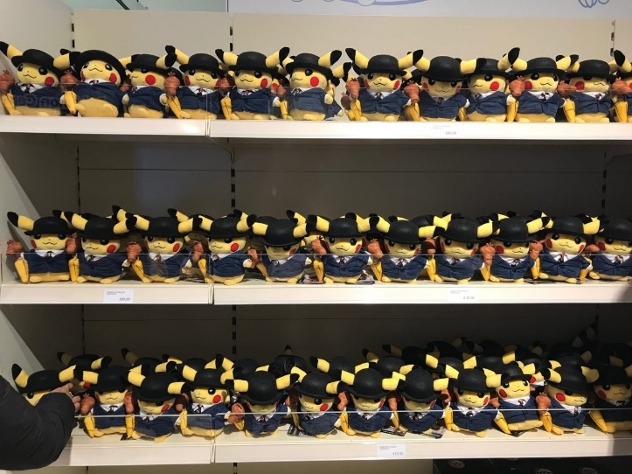
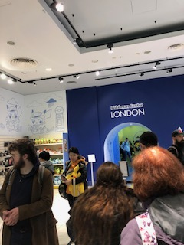
Despite the queue covering virtually the whole of the top floor of the shopping centre and taking at least a few hours to actually get into the store, there was still a good variety of stock left. There were two sections of the store each dedicated to products which weren’t available anywhere else in the world.
James Robinson, BCU
Daniel and Sam from Cheltenham were two of the Pokémon fans who travelled to London and queued for many hours. “this is our first Pokémon centre experience. We are saving up to visit the Tokyo store, but the sheer sight of shelves filled with Pokémon items is really worth the wait.
According to the Pokémon company, more than 30,000 people visited the store. This was higher demand than expected but clearly, people want it to return permanently. Some fans have even set up a change.org petition. Will the store return, fans will have to wait and see.

