Gorillaz come to Birmingham for their most spectacular tour yet.
On the 2nd of December a band that has merged Pop, rock, electronic, rap and hip hop performed in the ‘Arena Birmingham’ to a crowd of over 15,000. Famous for hits such as “feel Good Inc” and “melancholy hill”, this animated band didn’t fail to blow any of their fans away.
The Gorillaz are an all virtual band created by Damon Albarn, (previously the lead singer of the hugely successful Blur) and Jamie Hewlett who is the bands artist. The bands virtual members include “2-D”, “Murdoc”, Noodle” and “Russell”. The band performed hits such as “Saturnz Burnz” and the highly anticipated “Clint Eastwood”. The whole arena was used for the enormous set and screen which projected the band members performing throughout the concert.
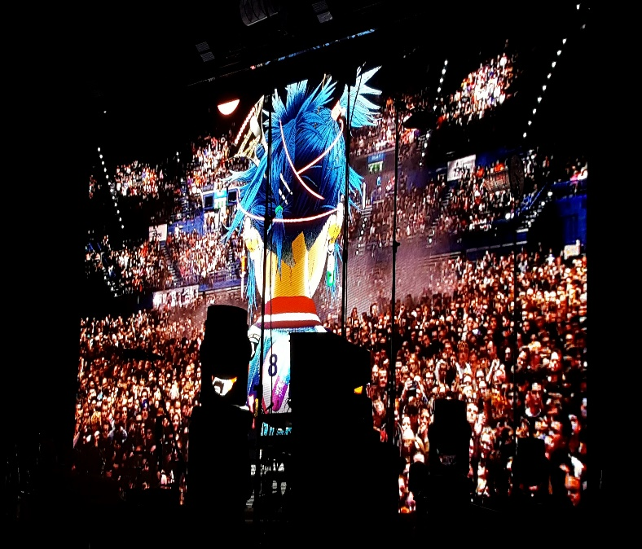
Jacob Marshall, a local resident who attended the concert and has been a fan of the band for many years commented on the concert afterwards. 'I'm a huge fan of the Gorillaz, I'm an avid music lover and Demon Days was the first album I ever bought. It was a massive moment for me to see them on stage.’
Image by Jacob Marshall
Demon days was one of the first albums that really helped the band rise to fame as Damon Albarn started to venture outside of British pop and start a new music journey. Albarn aims to have the band perform in a fully virtual setting where they can play live without Albarn and the other guest singers. This was attempted at the Grammys, but wasn’t as successful as originally hoped for.
Jacob also added, ‘Because a lot of their tracks involve other guest artists, it was a real showcase of guests with each one putting their own musical spin on the tracks from the albums. They have arguably created their very own genre of music.’
Another fan of the band, Sharnna Gilsenan a Birmingham student stated that ‘Gorillaz was a great way for Albarn to branch out into new areas of music. Moving away from blur and Britpop to experiment with new genres.’
‘the best performance musically that I’ve ever seen’ said Sharnna.
The Gorillaz clearly left fans with memories that others would struggle to achieve, as their concerts are so unique, so mesmerising and so powerful that their fanbase spans across the world and into the hearts and minds of anyone who likes great music.

