Article 3
Great British Bake-Off star dreams of his café being the “most instagrammable in Birmingham”
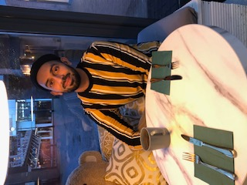
Cocoa by Ali, tearoom and patisserie is hoping for success second time round after being closed down when in grand central.
Ali Imdad, entrepreneur from Alumn Rock who was a contestant on the Great British Bake-Off in 2013 participated in an exclusive interview discussing the success of his café and where he hoped to take it in the future.
“Cocoa was always my dream, having a café that’s the prettiest to be inside and makes you envious to look at from the outside”.
“After opening on the canal business has thrived so we definitely think it’s time for the next step in Cocoa’s journey.”
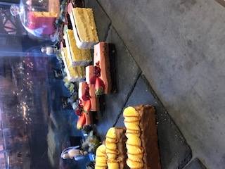
Ali got into baking after his last role as a chef and made his name on the Bake off. Ali said, “everyone likes cake, I wanted to make a stunning café, which specialises in the best cakes. The most instagrammable café in Birmingham”. Clearly Ali has succeeded and has set his sights to Leicester, where he studied business and marketing. Clearly Ali is comfortable there and knows his audience will love it.
Credit, James Robinson, BCU
Credit, James Robinson, BCU
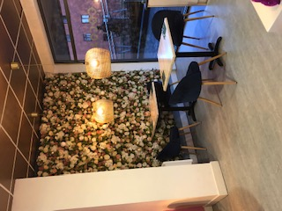
I asked about how he can top the success of Birmingham Cocoa. A cosy café full of flowers and colour, yet Ali knows exactly what he’s doing. He said, “we are planning to open in Leicester in the next few months. The place we’ve got is triple the size so it can be like a restaurant, bigger menu, bigger lights and more instagrammable.”
Credit, James Robinson, BCU
Ali has also managed to land a book deal with an agent in London. His book, about characters that have lived in a previous life, and are facing the challenges of a modern world is Ali’s first attempt at writing a book, and he already has plans for a second.
“writing this book has been so exciting, I already have plans for a sequel already.”
Clearly Ali’s fans have a lot to look forward to this year.

