Article 2:
Birmingham’s Frankfurt Christmas market “needs a re-think as to how it’s structured” after local business is denied a stall at this crucial time of year.
The Birmingham Frankfurt market has caused difficulties for local businesses at Christmas, after the council denies a prominent local business the space to sell alongside the German stalls.
The Frankfurt Christmas market in Birmingham is an annual event which attracts thousands of visitors from all across the UK, every year people gather to buy the famous frankfurter sausages or try the Berliner donuts which are always so popular. Birmingham mail reported that 5.5 million people visited the markets just last year.
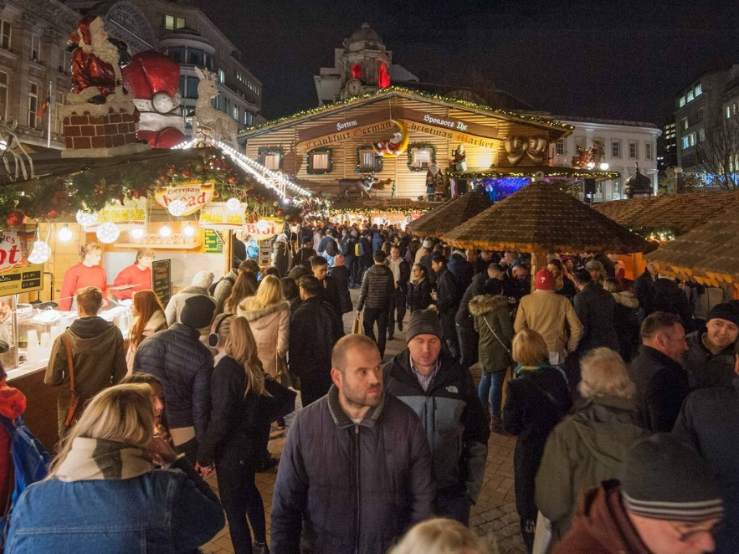
This sounds great for businesses; however, The Birmingham Whiskey Club was left without a stall and the chance to benefit from this massive flow of people. After reaching out after they tweeted about not being allowed to trade alongside the German stalls, the owner Amy Seton described her experiences as a business owner at this time of year.
“I love the idea of an urban Christmas market, but it needs a re-think as to how it’s structured” Amy said.
“Having been in the city or over ten years, I don’t find us locals who live and work here getting particularly excited about it anymore”.
“It keeps people in the city centre away from other parts of the city like the jewellery quarter and I know other bars and restaurants have suffered because of it.”
The German market is very successful however local businesses are suffering like Amy’s and they all want the chance to trade in the centre where all the people are. “there used to be an area by chamberlain square which had non traditional stalls.” This area gave local businesses the chance to trade amongst the other stalls.
German Market, 2019. Credit, Birmingham Mail.
In response to how The Whiskey Club Birmingham plans to challenge the denial from the council to have a stall, Amy said, “I don’t have any definite plans, but I have noticed a proper backlash from Brummies in support of us this year. Watch this space.”
Clearly people in the city want their favourite businesses to get the same opportunities as the visiting German markets, and time will tell if next year will be any different.

